This is the current draw as shown in the Nordic PPKII for the Adafruit Huzzah 32 board running the LPGASSENSOR sketch.

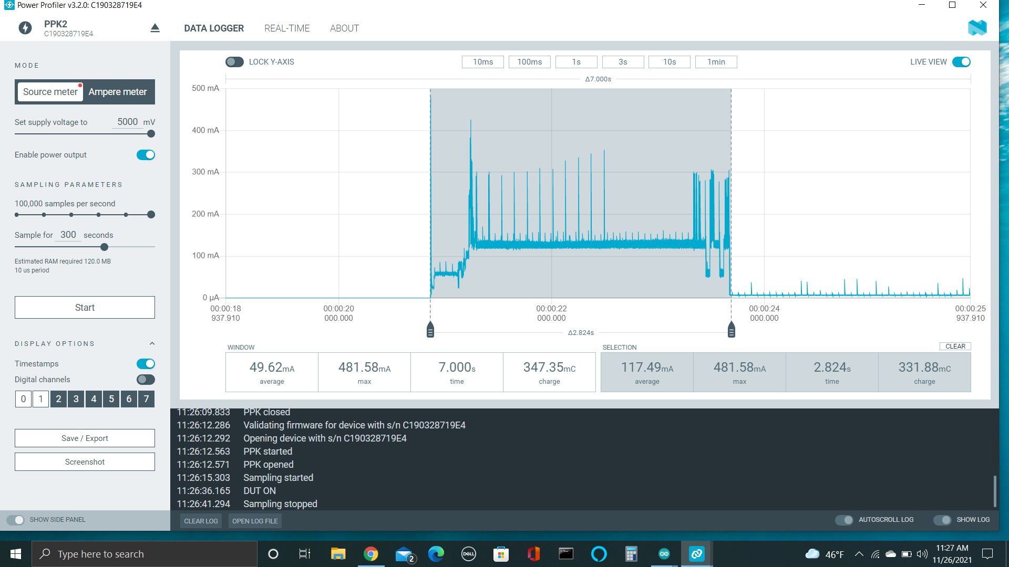

The wake up period shows an average current draw of 117.49ma with a max of 481.58ma. This is for a duration of 2.824 seconds (roundup to 3seconds). The charge consumption is 331.88uc.

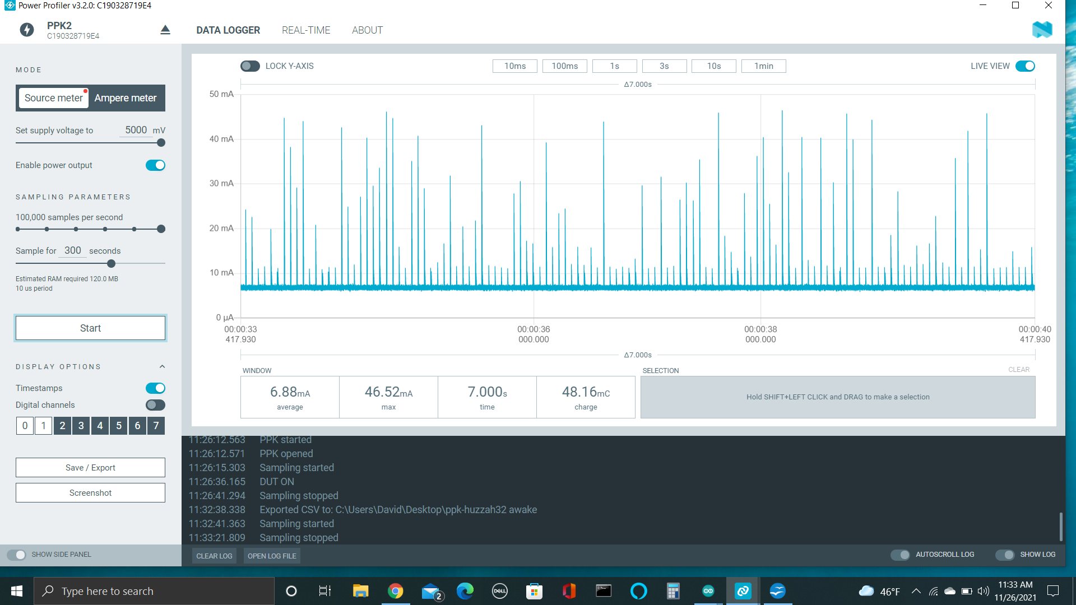

The deep sleep period shows as average current draw of 6.88ma with a max of 47.44ma. The charge consumption is 412.26uc for a period of 1 minute.

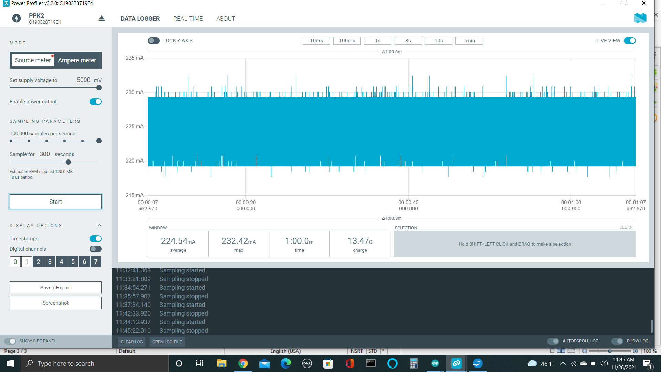

With an 18650 battery plugged into the board, it draws roughly 225ma with a max of 232.42ma. For a period of 1 minute, the charge consumption is 13.47c. This is for a battery that is mostly already charged up. It should be noted that the nordic PPKII was supplying ~4.6volts to the usb pin.

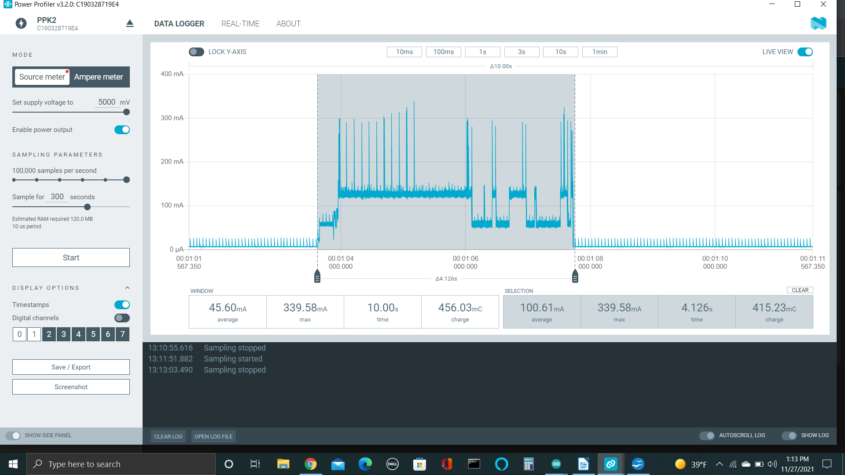

With everything hooked up, the average current consumption was 100.67ma. The max current was .339.68ma. The total wake up period was 4.1 seconds and this was using DHCP for the ip address. The total charge was 415.23uc.

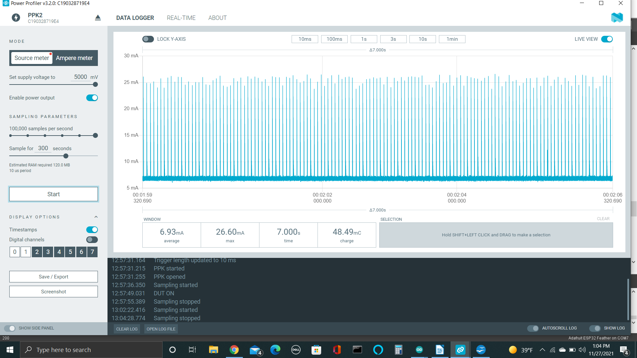

With everything hooked up and in deep sleep the average current was 6.93ma. The max current was 27.2ma. The total charge consumption was 415mc.

The Huzzah 32 wiring

USB pin goes to the boost convertor output.. Orange wire
Gnd goes to GND

power for the LP sensor goes to GPIO 21
LP Sensor output goes to A3

Solar panel output goes to top of 200k resistor voltage divider
The middle connection of the voltage divider goes to pin A4

